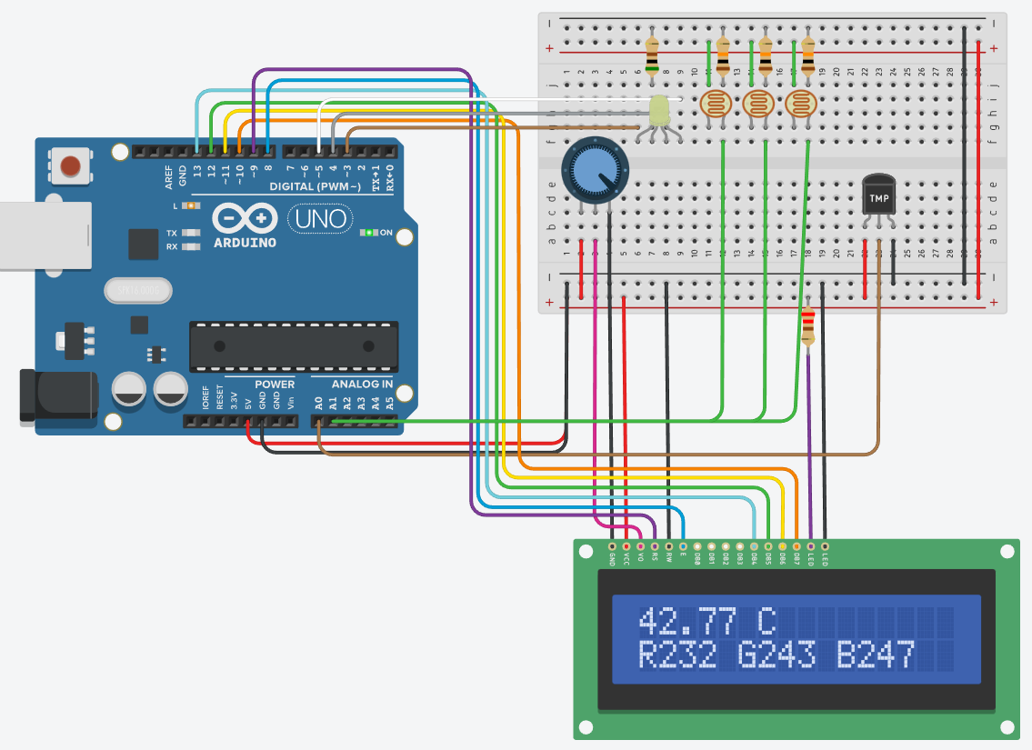

#include <LiquidCrystal.h>
LiquidCrystal lcd_1(9,8, 13, 12, 11, 10);
void setup(){
Serial.begin(9600);
lcd_1.begin(16, 2);
pinMode(A1, INPUT);
pinMode(A2, INPUT);
pinMode(A3, INPUT);
pinMode(5, OUTPUT);
pinMode(4, OUTPUT);
pinMode(3, OUTPUT);
}
void loop(){
int R=(analogRead(A1)-54)/3.6;
int G=(analogRead(A2)-54)/3.6;
int B=(analogRead(A3)-54)/3.6;
analogWrite(5,255-R);
analogWrite(4,255-B);
analogWrite(3,255-G);
double SensorVal = analogRead(A0);
SensorVal = (SensorVal * 5);
SensorVal = (SensorVal / 1024);
SensorVal = (SensorVal - 0.5);
SensorVal = (SensorVal * 100);
lcd_1.setCursor(0, 0);
lcd_1.print(SensorVal);
lcd_1.setCursor(6, 0);
lcd_1.print("C");
lcd_1.setCursor(0, 1);
lcd_1.print("R");
lcd_1.print(R);
lcd_1.setCursor(5, 1);
lcd_1.print("G");
lcd_1.print(G);
lcd_1.setCursor(10, 1);
lcd_1.print("B");
lcd_1.print(B);
delay(100);
}

